Threat management and cybersecurity Resources

Key contributors:

Devon Brown

Daniel Garza

Candan Martin

April/15/2022

**Executive Summary(Daniel)**

The purpose of this project is to provide an in-depth comparison of open source vulnerability assessment scanners(VAS) and the result of their analysis of several operating systems. We will be performing these assessments primarily using the same tools then using tools unique to each software suite. Finally, we will be consolidating our TVA documents into a report that includes a description of each VAS and our experience with them.

Github:<https://github.com/dsgarza/Computer-Systems-Security-Project.git>

Trello:[https://trello.com/b/D8nc0ssm/comp-sys-sec-project#](https://trello.com/b/D8nc0ssm/comp-sys-sec-project)

Project Milestones: (Candan)

Milestone 1

-Proposal

Description:

Our team will brain storm a topic to implement in our project and present our project idea to our professor Gonzalo

Milestone 2

Develop Plan for project

Description:

Our team host a meeting at UIW to discuss what we will need to do for our project and layout a plan on how we should work on project.

Our team came to the conclusion that we would

1st. Identify softwares we would use

2nd. Identify Operating Systems to scan for vulnerabilities

3rd. We need to set up a NAT configuration to create isolated environment

4th. Set up attacker OS and target OS, run software to scan OS, record steps to use software, generate report, and upload our work into our group GitHub repository

5th. Set up tasks for team members on our Trello account to show the progress of the team

Milestone 3

Identify Software and Operating Systems for operation

Description:

Our team came to the conclusion to use Nessus, Openvas, and Metasploit to scan the operating systems Fedora, CentOS, and Metasploitable

Milestone 4

Develop a network for virtual machines

Description:

Our team configured our VMS to a NAT configuration to isolate them from our home networks

Milestone 5

-Execute Software on operating Systems within the network

Install software Nessus, Openvas and, Metasploit

Execute software on Attacker VM to scan for vulnerabilities in target operating systems Fedora, CentOS, and Metasploitable

Milestone 6

-Record, analyze, and then discuss with the team data

Take snap shots of steps used to execute software in word document

Generate vulnerability reports from software and upload to the github repository of the group

Meet with team to discuss which software was most effective and what operating system was most secure

Milestone 7

-Create a Slide presentation

-Submit Report

**Current Status of Project:(Candan)**

* Project is complete and software have been used to scan three operating systems for vulnerabilities

Next Steps:(Candan)

* Present project and submit onto Canvas assignemnets page

Expected Outcomes:(Candan)

* Have a model for a real-world implementation for our topic
* Know when specific sections of project need to be completed by to stay on time

**Deliverables**

**Deliverable 1.**

**Add member tasks in Trello Account-Link in table of contents**

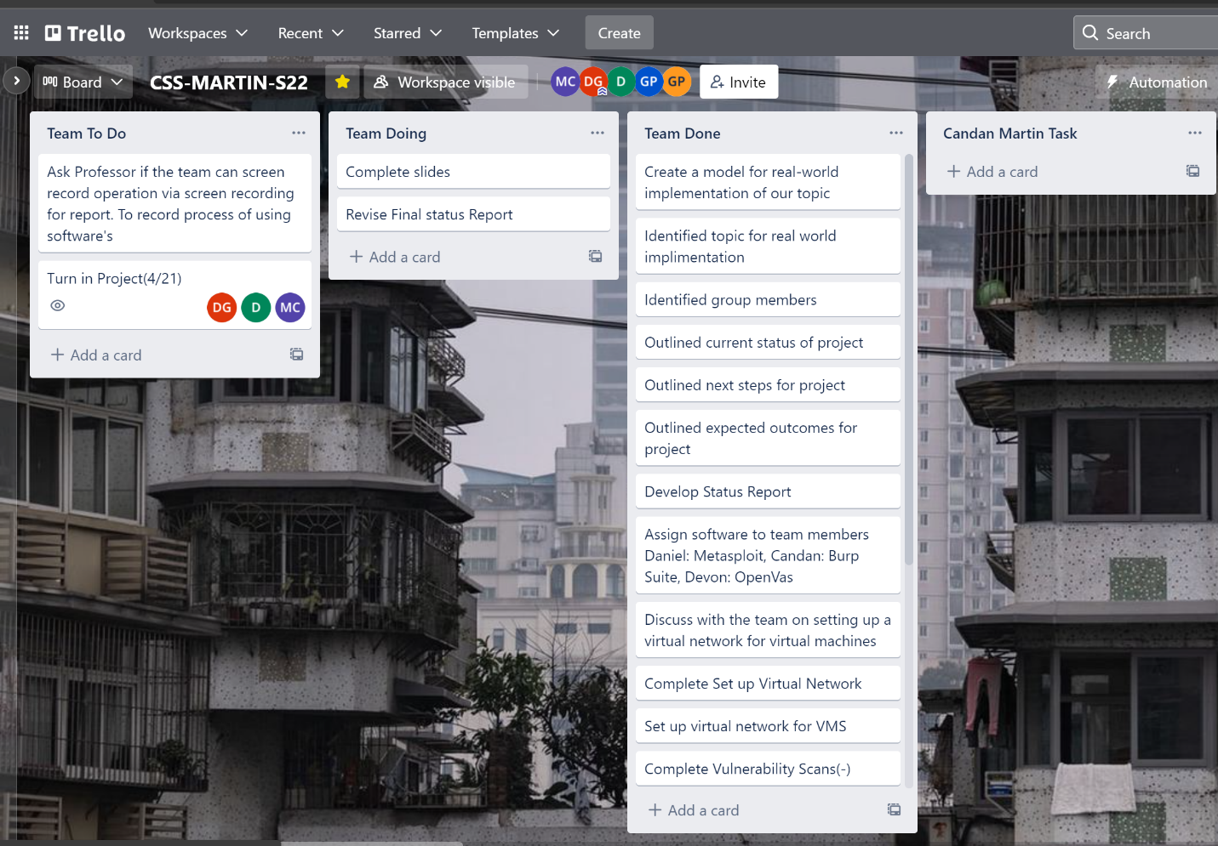

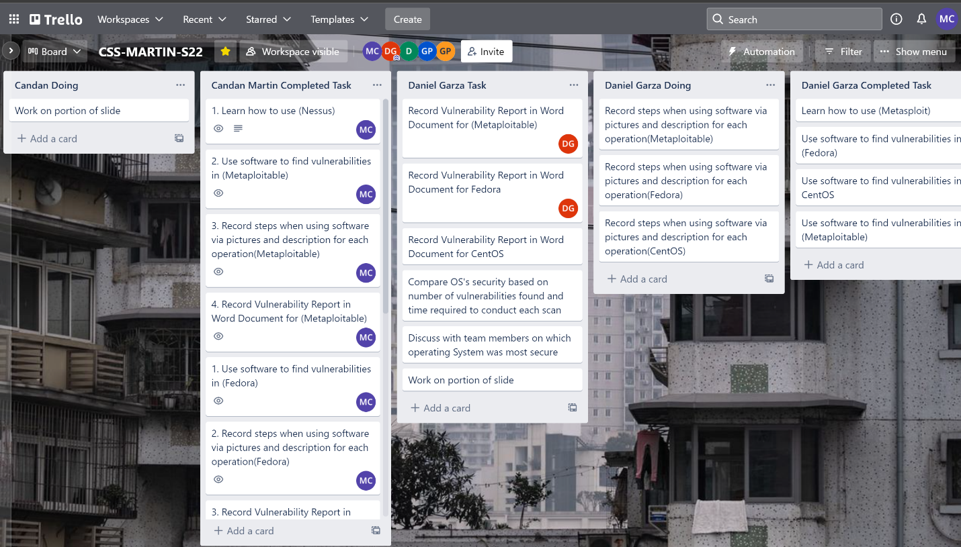

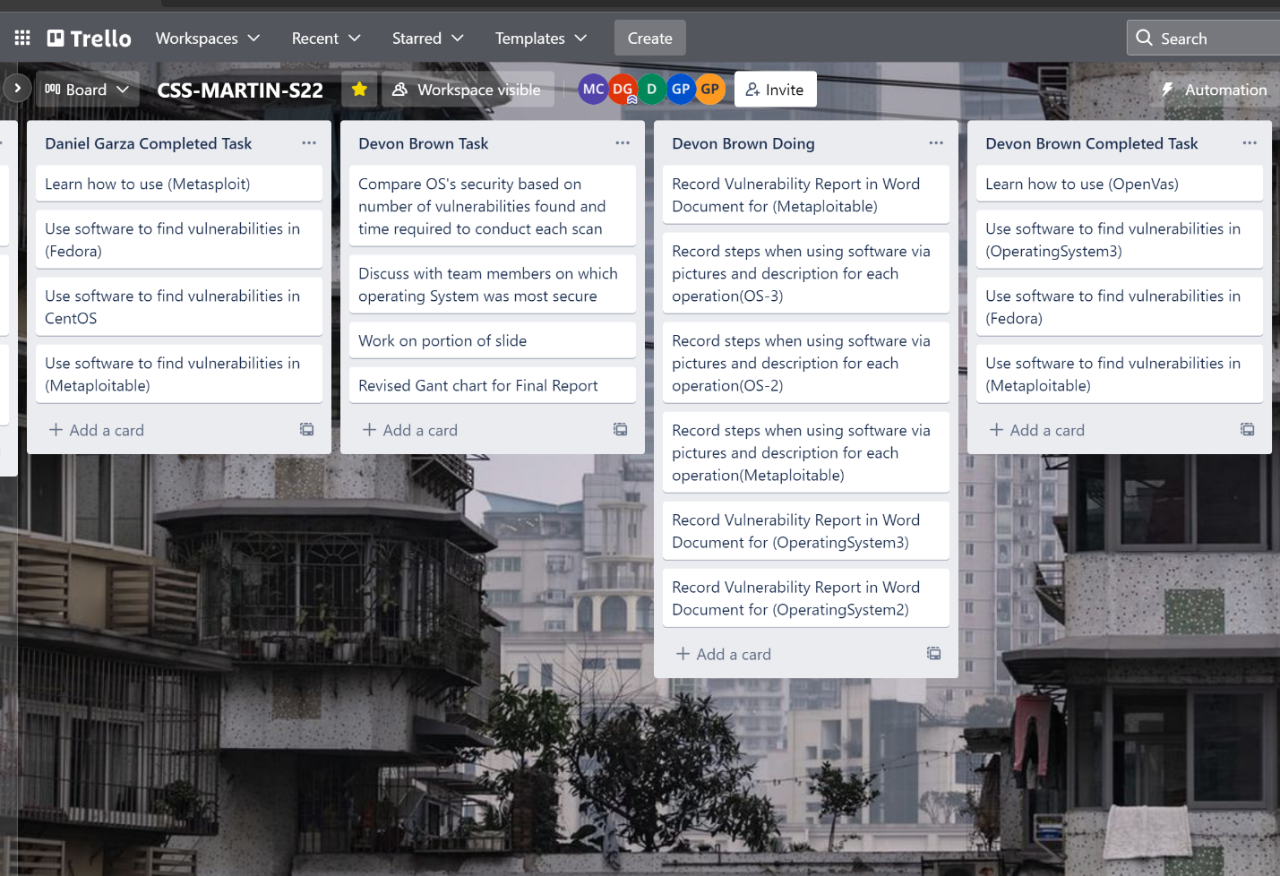

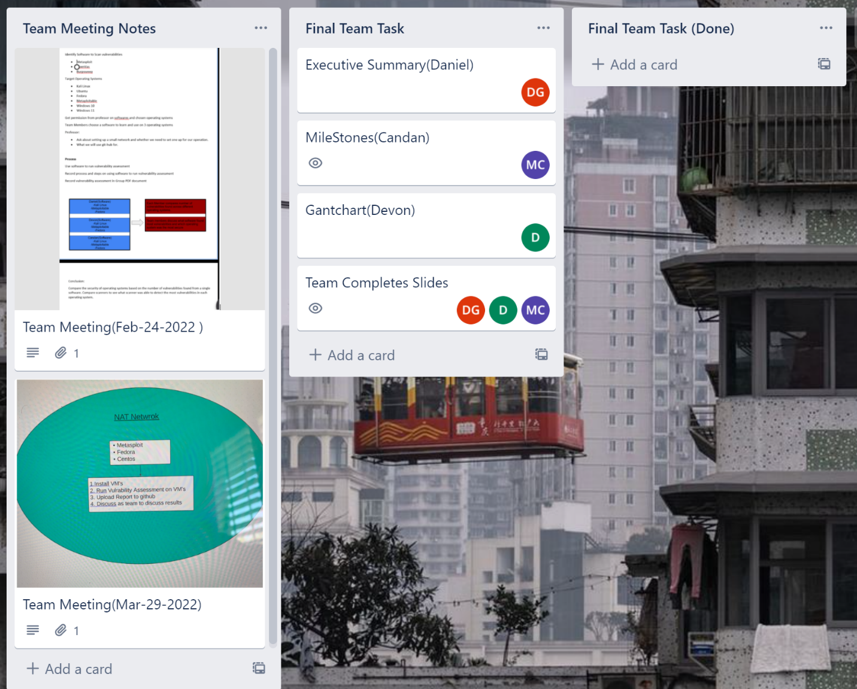

**Deliverable 2.**

**Documents showing how we used software and our generated reports were uploaded to team GitHub-Link in table of contents**

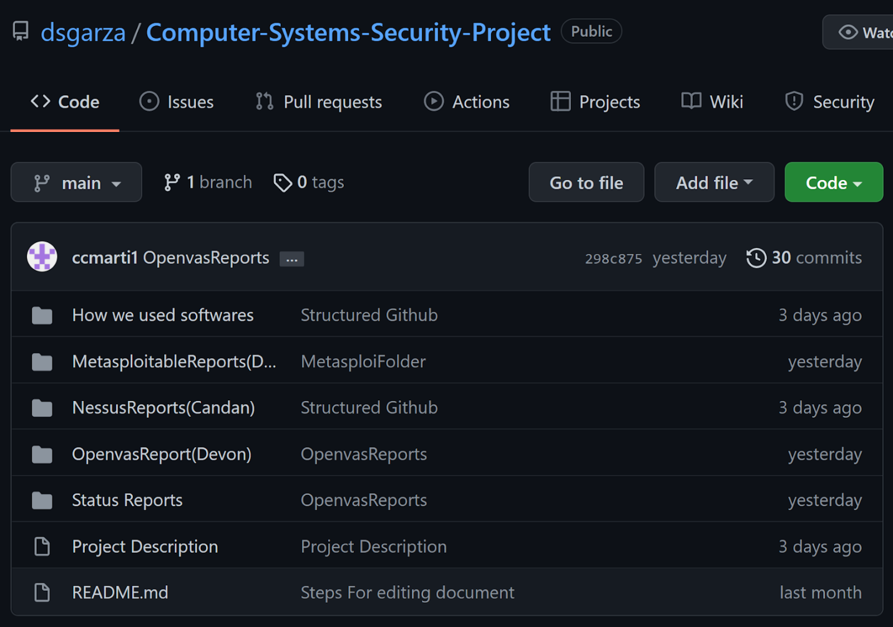

**Deliverable 3.**

**Presentation Slide Made- Link in table of contents**

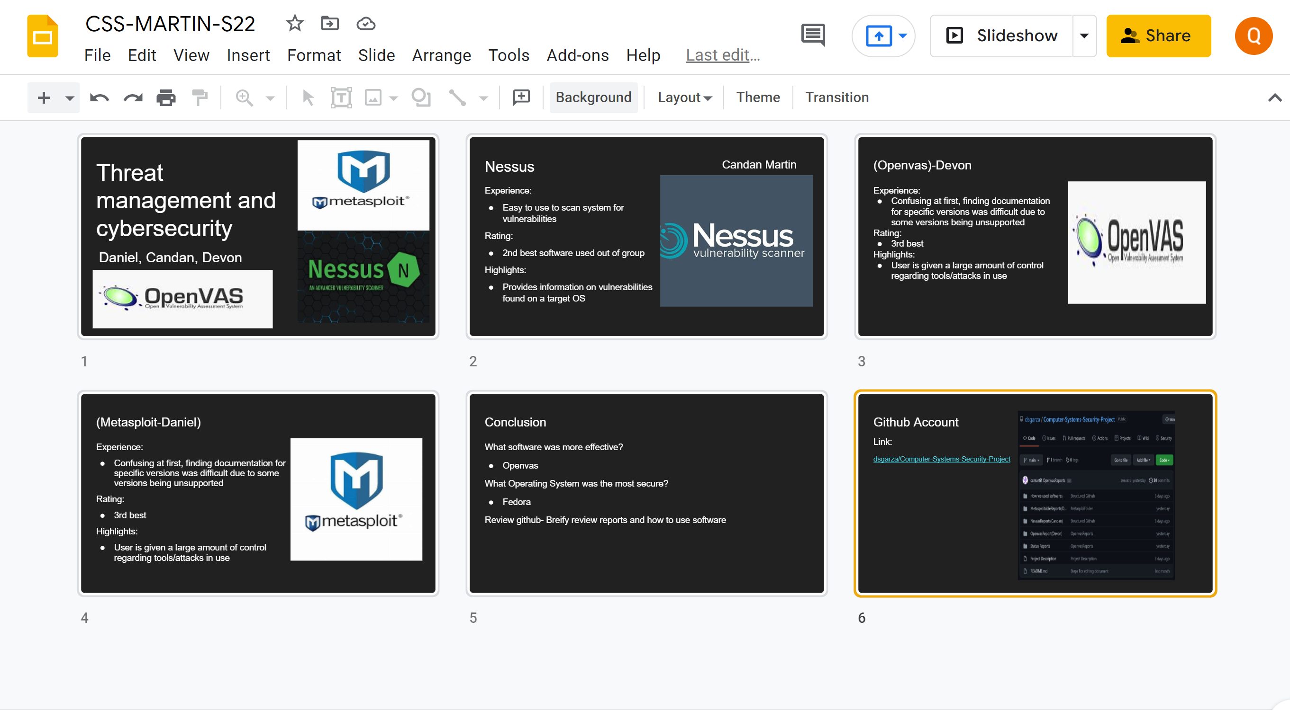

**Professional Accomplishments**

1. **Learn to work in a collaborative environment in a team**
2. **Development of skills on project management and constructing a plan to implement a task given. Our task given was implementing the topic our team chose.**

**Individually**

**Candan-**

1. **Learned how to use Nessus to scan operating systems**
2. **Learned how to structure plans for project implementation and collaborating with team for ideas**
3. **Learned how to configure NAT network**

**Daniel-**

**Put what you were able to learn during project. Maybe software and managing software issues**

**Devon-**

**Put what you were able to learn during project. Maybe software and gantchart**

**Project Schedule Management**

Gantt chart(Devon)

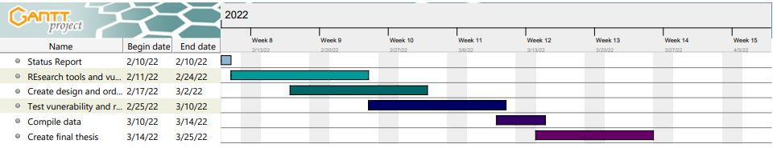

COMMENTS

-Gonzalo Parra just made a new comment on the submission for Candan Martin for Status Report

Excellent, make sure you **build some good case scenarios** and **present their corresponding demos.** Also, make sure you **follow the format I provided** you. Make sure you **update your Gantt chart and Trello** as soon as you start defining the tasks for each milestone.(**Once you start defining task for each milestone**)

